Accreditation form for requesting the translation
of the STAB and / or the Brux Screen

Attention! The publication of scientific articles on bruxism indexed on PubMed/Medline is a fundamental prerequisite for accreditation as an STAB translator.
As the team leader for the translation project, please complete this form in all its parts so that we may assess your qualifications. Submit this form, converted to PDF format, to this email address: info@bruxism-project.com
This request will be reviewed, and a response will be sent to you via email.

¨ Request for Assignment to Translate the STAB into the Language:................................................................................
¨ Request for Assignment to Translate the BRUX SCREEN into the Language:................................................................................

- First Name: - Last Name:
- City: - Country:
- Age: - E-mail:
- Professional Title:
- University:
- PhD:
- Academic Roles:
- Research Projects:

- List of conferences and congresses as a speaker:

- List of publications on bruxism:

Please enter the names and roles of the team members who will work on the translation.

Translation team
Project leader:
Team leader:
Study coordinator 1:
Study coordinator 2:
Study coordinator 3:
Forward translator 1:
Forward translator 2:
Back- translator 1:
Back- translator 2:

Collaborators
Expert panellist 1:
Expert panellist 2:
Expert panellist 3:
Expert panellist 4:
Expert panellist 5:

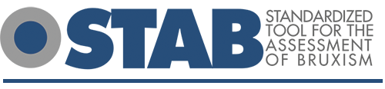
www.bruxism-project.com - info@bruxism-project.com

